Case Project 1

Mr. X, aged 45, is a working professional in the private sector looking to invest his surplus funds in various asset classes.

He has around Rs. 50 lakhs for investment. If we categorize his risk score earlier, he was 30/100, which can be categorized as a risk-averse investor. Now, his risk score has increased to 47/100, making him a risk-neutral person. For Mr. X, if the opportunity prevails, he is ready to take more risks in the market.

If his risk score increases above 70, he would be categorized as a risk-loving person.

For his investment, he is looking for a compounded annual growth rate on his investment from 15% - 18%, and the time frame for his investment is 5 years. Debt is fetching a rate of 7%, while equity is fetching a rate of 13.5%. Currently, there is short-term volatility in the futures & options market.

The funds that he is considering are composed of Equity, Debt, and Futures & Options.

Fund A - Debt: 50%

Equity: 30%

Futures & Options: 20%

Risk Score: 40/100

Fund B - Equity: 40%

Debt: 40%

Futures & Options: 20%

Risk Score: 55/100

Fund C- Equity: 40%

Debt: 30%

Futures & Options: 30%

Risk Score: 65/100

Create a scenario table for each fund, and determine the percentage of targetted return that futures & options should fetch so that Mr. X achieves the desired return on his investment.

Based on your analysis, in the first part of the question, which fund should Mr. X pick as per his risk-taking appetite so that he has maximum chances of getting his desired return?

In this part of the question, you have to create an optimal investment strategy for Mr. X - keeping into consideration that you have to allocate 20% to each asset class - equity, debt, and futures & options.

A. For Mr. X’s profile and risk appetite, find an Indian mutual fund in the debt and equity segment that would suit Mr. X’s risk appetite and also state the fund’s historical returns (5 years). Mention the percentage allocation of overall portfolio value that you would assign to these funds and the reason for the same. Also, give a brief profile of the fund manager in charge of this mutual fund.

B. State the percentage of the portfolio value that you would advise Mr. X to trade within the futures & options market to accelerate his quest for returns and mention the expected return that Mr. X would get through this investment strategy.

Case Project 2:

Consider the following situations:

Situation 1

A stock investor, Mr. B has many of his holdings in a chemical company. The sector has been facing constant pressure due to factors like supply issues and an increase in raw material prices. The stock can be categorized as a mid-cap segment share. Mr.B can be categorized as a Risk-Averse investor (A person who hates taking risks and would only take risks if the risk-reward ratio is favorable).

Due to the uncertainty in the sector, the stock-associated risk has increased and is going beyond the tolerance level of the investor. In a week, the quarter results of the company will be announced, and already the volatility has spiked in the share.

The investors are speculating over the margin improvement and the management guidance of the company as the peers delivered sab par and poor results. Considering the above situations, the investor is trying to evaluate how he can hedge his position so that when the results get announced and if the results are subpar, he can restrict his losses, but at the same time, he does not want to lose out on potential gains. His average cost of buying the stock is Rs. 95, and currently, the stock is trading at Rs. 100. An Option is available with a strike price of Rs. 100 and option premium of Rs. 3, slated to expire in a week, coinciding with the result announcement of the company.

Based on the market expectation and volatility, if the company's results are sub-par, then the market price is expected to be around Rs. 90 - 95, while if the results are above expectation, the price is expected to be around Rs. 105 - Rs. 110. The probability of a sub-par result is 0.6, while the probability of an above-par result is 0.4.

Consider the following conditions:

1. Mr. B buys a call option by paying a premium of Rs. 3 with a strike price of Rs. 100.
2. Mr. B buys a put option by paying a premium of Rs. 3 with a strike price of Rs. 100.

For both conditions, create a tree stating a bullish and bearish scenario. Indicate when he would exercise the option and when would let it expire. If possible, share the expected payoff of exercising the option today.

Situation 2

ABC Ltd is a trading company in India which deals in plastic manufacturing. They source their material from China and sell it in the USA and European Union. Material sourcing is done in Yuan, and sales are done in Dollars and Euros. As their business is international, they are exposed to currency fluctuations and currency risk on both the purchasing and sales sides. The typical business cycle of the company is:

Day 1: ABC Ltd. orders with the Chinese vendor and pays 30%.

Day 30: The Chinese vendor loads cargo, and ABC Ltd makes 70% of the payment to the Chinese vendor.

Day 45 - 50: ABC Ltd. receives orders from US and European customers for its products and gets 10% as advance payment.

Day 60: The goods are received in India

Day 90: Goods are shipped to US and Europe after value addition at ABC Ltd’s factory near Mumbai

Day 135: Goods are delivered in Europe, and the balance of 90% of the payment is received

Day 180: Goods are delivered in the US, and the balance 90% of payment is received

The finance team of the company is trying to work out a plan of action or strategy to use futures & options to mitigate the currency risk associated with the business. Please point out the various points in the business model where the company is exposed to currency risk. Kindly suggest suitable futures or options instruments that can be used to mitigate the same.

## Case Project 3:

The below represents the option chain data of a Stock Index. It is one of the most popularly traded indexes in the Indian market. We have provided you with two different time period data for market analysis. Please find the attached data:

During the 1st Half of the Market:

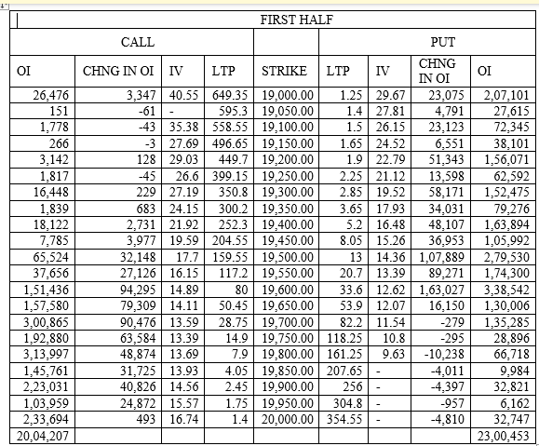

During the 2nd half of the market:

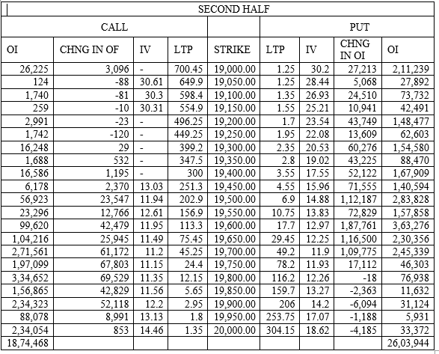

1. Looking at the given option chain data, calculate the Put Call ratio for the 1st and 2nd half and give an appropriate interpretation of the sentiment in the market.
2. Based on the data, find out the support and resistance levels in the market.
3. Based on the above-given data, create a payoff table for any two suitable option trading strategies and explain the payoffs at different spot prices of the index. You can pick any two strategies that you wish to.